INTRUSION-RELATED GOLD SYSTEMS OF THE CHARTERS TOWERS PROVINCE, NORTH QUEENSLAND

Gregg Morrison and Simon Beams
Klondike Exploration Services, 7 Mary St, Townsville, Qld, 4810
Terrasearch Pty, Ltd, 21 Keane St., Currajong, Qld 4812
Key Words: Intrusion-related Gold System, Charters Towers, gold, domains, multi-element geochemistry

Abstract
There are more than 70 defined Permo-Carboniferous Intrusion-related Gold Systems spread across the Charters Towers Province of north-east Queensland. The majority have been emplaced at mesozonal or porphyry level and exhibit a range of styles dominated by vein complexes and breccias. A recent review has highlighted that many of the systems contain felsic and mafic intrusions both of which develop hydrothermal systems but with different metal assemblages. There are also different metal assemblages controlled by the composition of the basement igneous rocks that define mappable basement domains. Current efforts to promote exploration activity in the region have focused on the recognition and definition of the IRGS systems in amongst a sea of orogenic vein occurrences. The main tools have been a detailed compilation of sub-volcanic complexes and dike swarms, vein and lode occurrences, magnetic anomalies that relate to alteration and hornfels around buried intrusive complexes and radiometric dating. Multi-metal geochemistry has also been used to develop a sophisticated classification of systems that reflect the composition of the genetically-related intrusive suites. There are also enough drilled systems in the region to define metal zoning patterns for a range of systems that in turn can be used to define the position of surface samples from systems with limited sampling. This leads to a ranking of systems as exploration targets.

Introduction
A recent review has identified ~130 Intrusion-Related Gold Systems (IRGS) that make up a distinct metallogenic province related to the Permo-Carboniferous Kennedy Igneous Association in the Townsville-Cairns hinterland of north-east Queensland. More than half of these systems are concentrated in the Charters Towers Province.
IRGS in the current review means a mineralised magmatic-hydrothermal system where gold is the dominant or only commodity and where there is a demonstrable genetic link to an intrusive complex. In north Queensland the IRGS are distinguished from turbidite-hosted orogenic gold deposits dominated by metamorphic fluids such as those in the Hodgkinson and Broken River provinces; from granite-hosted orogenic deposits dominated by crustal fluids of mixed origins such as the Charters Towers or Etheridge Goldfields; and from the epithermal gold deposits dominated by meteoric fluids such as Pajingo and Wirralie in the Drummond Basin. There is ~40Moz of total identified gold endowment in north-east Queensland of which nearly half is in IRGS deposits and 6 of 11 deposits with >1Moz Au are IRGS. This alone marks north Queensland as a significant IRGS metallogenic province. In the Charters Towers Province there are 74 IRGS systems with an endowment of >10Moz.

Geological Setting
The north Queensland IRGS are genetically linked to the Early Carboniferous (345Ma) to Early Permian (~260Ma) Kennedy Igneous Association (KIA) whose main volcanic and plutonic phases are concentrated in the NW-trending Townsville-Chillagoe-Mornington Island belt. This belt is oblique to the northerly trend of the contemporaneous andesitic volcanic arc, fore-arc and subduction complex in central and southern Queensland. The KIA is dominated by cauldron subsidence complexes and batholiths along the main trend and peripheral sub-volcanic complexes along numerous discrete northeast and northwest-trending lineaments. This pattern is indicative of dominant extension during magmatism. The KIA is dominated by strongly fractionated I-type magmas derived from a homogeneous mainly Proterozoic lower crust with limited mantle input and regional variations controlled more by fractionation than shallow crustal interactions. Early Permian A-type volcanic and sub-volcanic complexes lie on the prominent lineaments and mark the final stages of the orogenic cycle. The overall metallogeny of the KIA is Au-Sn-W-U which is quite distinct from the Cu-Mo-Au metallogeny of the contemporaneous arc and is particularly notable for the absence of significant Cu deposits in the KIA.
The Charters Towers Province is the best exposed part of the early Paleozoic Thomson orogen in Queensland. The basement rocks are Proterozoic passive margin sedimentary rocks metamorphosed to upper amphibolite and migmatite grade. This is overlain by Cambro-Ordovician sedimentary rocks and felsic volcanics in the Mount Windsor sub-province and intruded by felsic granitoids of the Ordovician Macrossan Igneous Association (490-460Ma), and intermediate granitoids of the Siluro-Devonian Pama Igneous Association (435-380Ma); bound and overlain by Late Devonian-Permian continental to shallow marine sedimentary basins; and intruded by the Carboniferous-early Permian felsic intrusive and volcanic rocks of the Kennedy Igneous Association (Jell et al 2013).

Style & Environment | n | ENDOW- MENT, t Au | Element Class | Core | Example
vein hypozonal | 8 | 1.4 | Au-As-Bi-Te+/-BM | none | Brookville
breccia mesozonal | 12 | 115 | Au-PM | Cu-Mo, Mo-W | Mt Leyshon
vein mesozonal | 30 | 64 | Au-PM-Te-Bi | Cu-Au, Cu-Mo | Far Fanning
vein nw mesozonal | 9 | 152 | Au-PM-Te-Bi | Cu-Mo, Cu-Au | Ravenswood
breccia epizonal | 4 | 33 | Au-PM-Bi-Te | Mo-W-Bi | Mt Wright
Vein network epizonal | 2 | 0.01 | Au-PM-Bi |  | Pentland
vein epizonal | 6 | 0.02 | Au-PM-Bi Te | all | Wellington Springs

Table 1: Summary characteristics of IRGS in the Charters towers province

Characteristics of Intrusion-related Gold Systems in north-east Queensland
Amongst the NQ IRGS there is a wide range of levels of emplacement of the igneous complexes, of mineralisation styles, metal associations (Figure 1) and mineralisation ages that span Early Carboniferous (Kidston, 335Ma) to Early Permian (Mt Leyshon, 290Ma). However, the majority of systems formed at the mesozonal (porphyry) level and are of the vein and breccia styles with a metal association characterised as Au-Ag-As-Sb-Cu-Zn-Pb-Bi-Te (+/- Mo, W). The dominant porphyry level of emplacement corresponds with the best deposits being found in sub-volcanic intrusive complexes dominated by porphyry intrusions away from the main volcanic-plutonic areas. This led to the name porphyry gold being applied to the clan of first recognised significant deposits (Kidston, Mt Leyshon and Red Dome; Morrison & Beams 1995) and is in contrast to the dominant plutonic level of emplacement of the typical Yukon-Alaska IRGS and their subtle, but significant differences (e.g. Hart, 2007).
The predominance of breccia, vein and stockwork over skarn-replacement deposit styles reflects that the typical host rocks are Si-rich and Fe- & carbonate-poor through much of the province. One exception is the Chillagoe district where carbonate and mafic volcanic rocks are common and the deposits are noted for higher concentrations of base metals that have been mined in their own right (e.g. Mungana Ag Pb Zn) or as co-products to gold (e.g. Red Dome Cu). There also some occurrences of this type in the carbonate sedimentary rocks of the Burdekin Basin in the Charters Towers Province. This highlights the fact that most of the systems are polymetallic in geochemical terms, but typically don’t have ore that is economic for anything other than gold and silver, at least under current mining conditions.

Basement domains and metal associations in Charters Towers Province
There are five basement domains that seem to influence the metal associations of the IRGS systems in the Charters towers province (Table 1).
The easternmost or Leichhardt domain has a basement of Mt Windsor volcanics plus the Ordovician granites and is characterised by plutonic to porphyry level systems with Mo-W-Bi cores, some iron oxide zones and a Au-Zn-Pb association. Mo-W occurrences that are interpreted as the core of zoned polymetallic systems are more common than Au systems in the northern part of the Leichhardt domain.
In the Ravenswood domain the basement is dominated by the Siluro-Devonian Pama tonalite-granodiorite-granite suite and the systems are polymetallic, but with Cu-Mo and Cu-Au cores and a Au-Cu-Bi associations. The systems are concentrated in the more mafic phases of the Siluro-Devonian intrusions especially on the eastern margin of the Ravenswood batholith. There are also more systems in this domain than the others where Permo-Carboniferous dioritic intrusions have Cu-Au cores and potential for Cu-Au orebodies as well.
The Macrossan domain includes the main areas of Ordovician granites peripheral to the Ravenswood domain and the main part of the Mt Windsor sub-province that is underlain by Ordovician granites. Sulfide-poor Mo-W-Bi systems with Au-Zn-Pb associations and a few Cu-Mo cored systems are more typical in the felsic basement of the Macrossan domain. The boundary between the Macrossan and Ravenswood domains is hidden beneath the Mt Windsor Volcanics and the late Devonian-Carboniferous Drummond, Burdekin and other basins. So even though the Mt Windsor sub-province has its own distinct basemetal VHMS association, the IRGS systems are different either side of the projected line that separates the Ravenswood and Macrossan domains.
The Tuckers domain is a distinct linear cluster of IRGS centred on and parallel to the early Permian Tuckers Complex and within the Ravenswood batholith so the IRGS systems have Au-Bi-Cu association with Cu-Mo cores or Cu-Au cores in the Siluro-Devonian host and a Au-Zn-Pb associations with Mo-W-Bi cores.
The Lolworth Sub province and domain has felsic basement of metasedimentary rocks and muscovite-biotite granites and the IRGS systems are sparse, Au-Bi polymetallic with Mo-W and some Cu-Mo cores like the Macrossan domain.

Use of Multi-Metal Geochemistry
Multi-element geochemistry has been successfully used to distinguish IRGS systems with notable Bi and Te enrichment from orogenic granite-hosted deposits such as Charters Towers that have a characteristic Au-Ag-base metal signature. It is also possible to distinguish the hypozonal IRGS with poor base metals from the mesozonal (porphyry-level) IRGS with a polymetallic signature and epizonal IRGS with significant As-Sb (Figure 1). In addition, there are metal zoning patterns that distinguish systems related to mafic, intermediate and felsic intrusions and the position of the best gold concentration that is progressively further from the intrusion from mafic to felsic (Morrison, 2015). This is a valuable tool for assessing the exposed position in a system and the best target zone for gold.

Conclusion
More IRGS in north Queensland have been identified by prospecting, mapping and geological interpretation than by any other method. The real challenge is an appreciation that an orebody is often only a small part of the overall magmatic-hydrothermal system and that the most commonly used tools, especially geophysics, identify parts of the hydrothermal system rather than ore. Hence, building a model of the 4D geometry of the system and understanding the scale of zoning and the controls on internal gold distribution are keys to effective exploration of the system. In the current constrained times, most new systems are likely to be found based on comprehensive desktop studies and most ore bodies from developing zoning models, especially for the multi-element geochemistry.
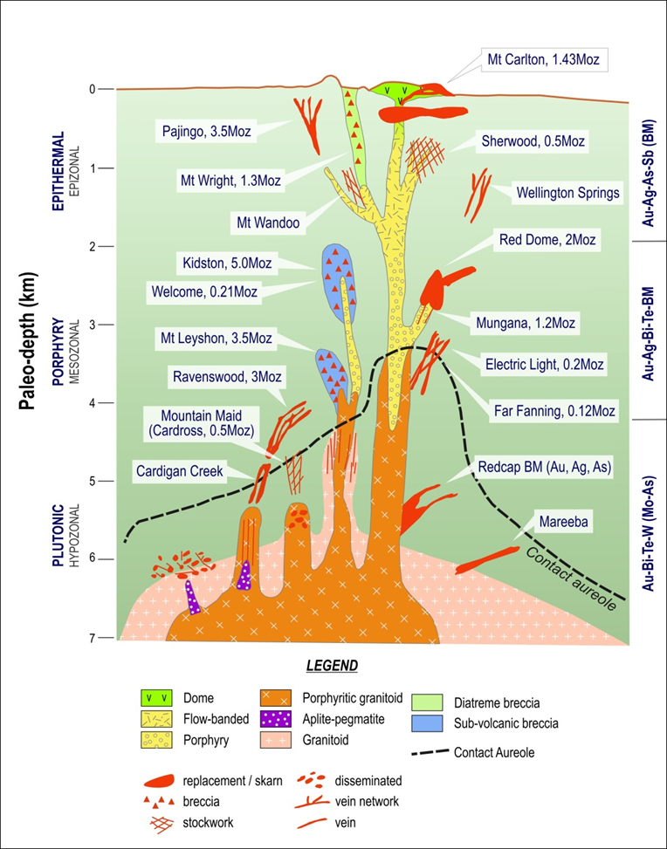

Figure 1: Cartoon model with examples of the environments styles and geochemical character of NQ IRGS.

Acknowledgments
This paper is a summary of some aspects of the project ‘Characterization of Intrusion-related mineral systems in the Charters Towers Region, Northeast Queensland’ which is a component of the Queensland Government Future Resources Program-Industry Priorities Initiative. The project is managed by Terrasearch Pty Ltd and Klondike Exploration Services and overseen by Vladimir Lisitsin of the Geological Survey of Queensland. We acknowledge co-operation by our major Industry Partners: Resolute Mining Limited; Mantle Mining, Ramelius, Liontown Resources and input from numerous other local exploration personnel as well as collaboration with EGRU at James Cook University.

References
There is a series of presentations on the recent work at http://www.terrasearch.com.au
Hart CJR (2007) Reduced intrusion-related gold systems. In: Goodfellow WD (ed) Mineral deposits of Canada: A synthesis of major deposit types, district metallogeny, the evolution of geological provinces and exploration methods: Geological Association of Canada, Mineral Deposits Division, Special Publication 5, pp 95-112
Morrison GW (2015). Interpretation of Multi-metal data for IRGS systems in Charters Towers Province; Seminar presentation Annual meeting Intrusion-related mineral systems in north-east Queensland. http://www.terrasearch.com.au
Morrison GW, Beams SD (1995) Geological settings and mineralisation styles of ore deposits of northeast Queensland. In: Beams SD (ed) Mineral deposits of northeast Queensland: Geology and Geochemistry. EGRU Contribution 52, James Cook University, Townsville, pp 1-32

